
AMERICAN INTERNATIONAL UNIVERSITY- BANGLADESH

Project: IMDB 5000 Movie Dataset
Course Title: INTRODUCTION TO DATA SCIENCE.
Section: C | Date of Submission: 16-08-2025
Semester: Summer, 2024-2025 | Course Teacher: DR. ASHRAF UDDIN

Group No: 9

No | Name | ID | Program
01 | MD TANJIL TASHRIK ZIM | 22-48021-2 | BSc in CSE
02 | MD. AL-IMRN SAYEM | 22-48023-2 | BSc in CSE
03 | MD. ABRAR RAFID SHARIAR | 22-48055-2 | BSc in CSE
04 | S.M. RASEL | 22-48039-2 | BSc in CSE

Faculty use only
FACULTYCOMMENTS | Marks Obtained
 | Total Marks

1. Introduction
This project analyzes the IMDB 5000 Movie Dataset, focusing on key attributes such as IMDb scores, budget, gross revenue, duration, and content ratings. The objective is to uncover patterns and trends that influence both a movie’s financial success and critical reception. To achieve this, the dataset was cleaned and preprocessed to ensure accuracy, followed by statistical analysis, visualizations, and predictive modeling techniques. Through descriptive statistics, correlation analysis, and regression models, this study provides valuable insights into how different factors interact within the film industry. The findings are intended to support filmmakers, researchers, and industry enthusiasts in understanding the dynamics behind successful movies.
Key column:
• imdb_score (numeric): IMDB rating of the movie.
• budget (numeric): Movie production budget in USD.
• gross (numeric): Gross revenue in USD.
• duration (numeric): Movie runtime in minutes.
• content_rating (categorical): MPAA or equivalent rating .
• genres (categorical): List of genres (e.g., Drama, Comedy).
• num_user_for_reviews, num_critic_for_reviews (numeric): Engagement metrics.
• num_voted_users (numeric): Total number of user votes.
• movie_facebook_likes (numeric): Facebook popularity.
• title_year, language, country (categorical): Production metadata.
2. Data Preprocessing Steps
Data Inspection
- Dataset size: 5,043 rows × 28 columns.
- Data types checked: Numeric (imdb_score, budget, gross, duration) and Categorical (content_rating, genres, language).
- Initial review showed missing values in several important columns.
Handling Missing Values
- Checked using colSums(is.na(movie_data)).
- Missing values found:
  - gross = 884
  - budget = 492
  - aspect_ratio = 329
  - content_rating = 303
- Action: Removed rows with NA values using na.omit().
- Justification: Ensures clean, complete dataset for reliable analysis.
Removing Duplicates
- Code removed duplicate rows using !duplicated().
- Justification: Prevents repeated records from biasing results.
Exploratory Data Analysis (EDA)
Univariate Analysis (single variable):
- IMDb Score: Mean = 6.44, Median = 6.60, Mode = 6.7, SD = 1.13, IQR = 1.40.
- Budget: Strongly skewed; most budgets under $50M.
- Gross Revenue: Right-skewed, dominated by few blockbusters.
- Profit: Wide variance; some low-budget movies achieved massive ROI.
- Duration: Mean ≈ 107 minutes; most clustered between 90–120 min.
- Histograms plotted for IMDb score, budget, and other numeric variables.
Multivariate Analysis (multiple variables):
- Scatterplot matrix: Relationships among IMDb score, budget, gross, and duration.
- Correlation heatmap:
  - num_voted_users ↔ imdb_score
  - num_critic_for_reviews ↔ imdb_score
  - budget ↔ gross weak
Data Wrangling
- Filtered only movies with gross > $100M (~12%).
- Selected key attributes (title, imdb_score, budget, gross).
- Created profit column (gross – budget).
Normalization & Scaling
- Scaled numeric features (imdb_score, budget, gross) for consistency.
- Justification: Ensures fair comparison and prepares dataset for machine learning.

3. Key Findings & Visualizations
Finding 1: IMDb Score Distribution
- Histogram shows majority clustered between 6–7.
- Insight: Most movies are moderately rated; very high or very low scores are rare. 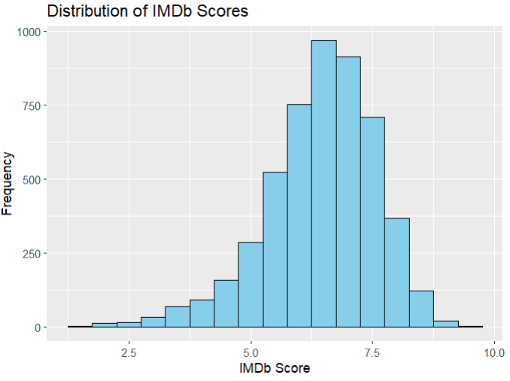
Finding 2: Budget vs Gross Revenue
- Scatterplot with regression line shows weak relationship (R² ≈ 0.01).
- Insight: Large budgets do not guarantee commercial success.
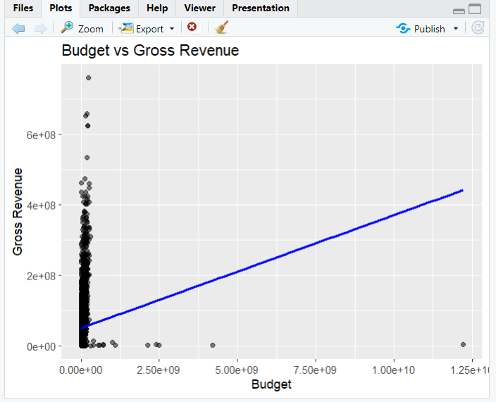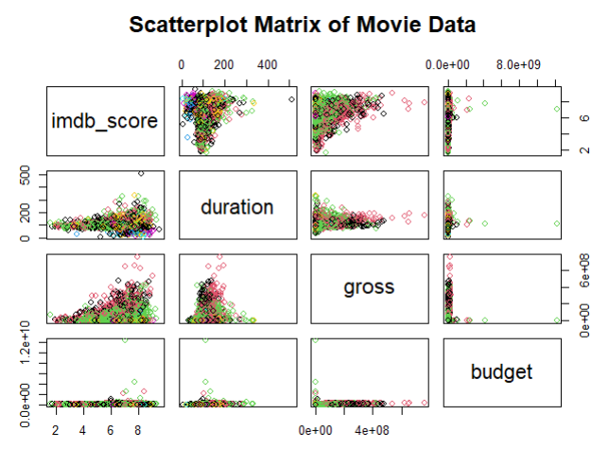
Finding 3: Boxplot of Gross Revenue
- Shows strong right-skew; a few blockbusters dominate revenues.
- Insight: Film industry follows a “long-tail” distribution.
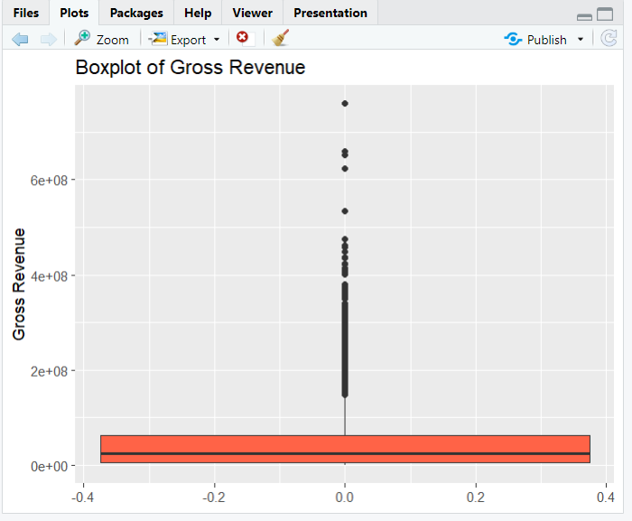
Finding 4: IMDb Score vs Profit
- Scatterplot shows a weak but noticeable trend that higher IMDb scores link to better profitability.
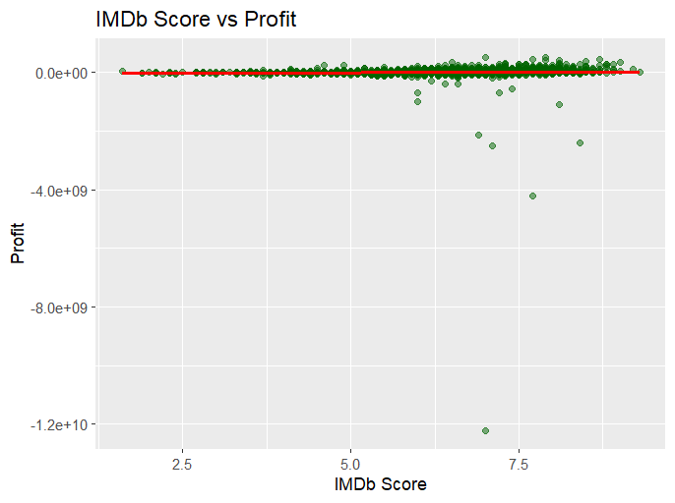
- Suggests critical reception may influence financial outcomes indirectly.
Finding 5: Correlation Heatmap
- Positive correlations between engagement metrics (votes, critic reviews) and IMDb scores.
- Insight: Audience engagement is a stronger predictor of ratings than budget is of revenue.
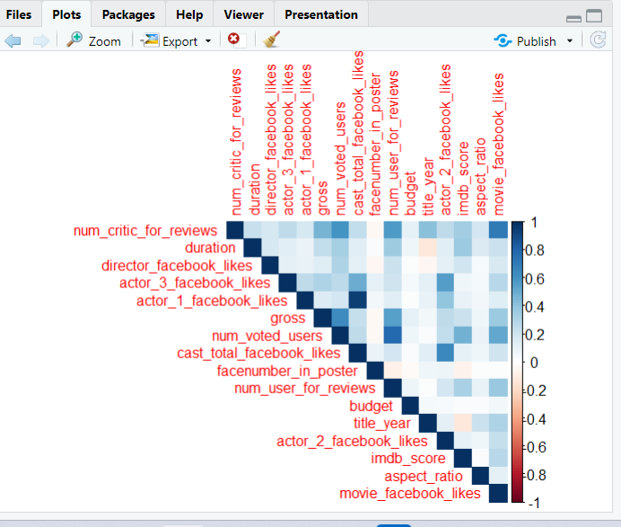
Finding 6: High-Grossing Movies (> $100M)
- Only about 12% of movies cross this mark.
- Derived profit metric highlights some low-budget films with very high ROI.
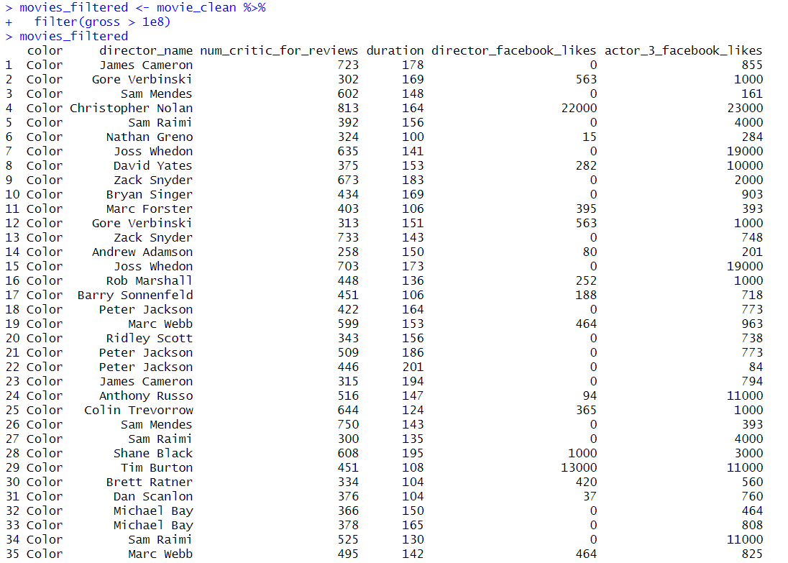
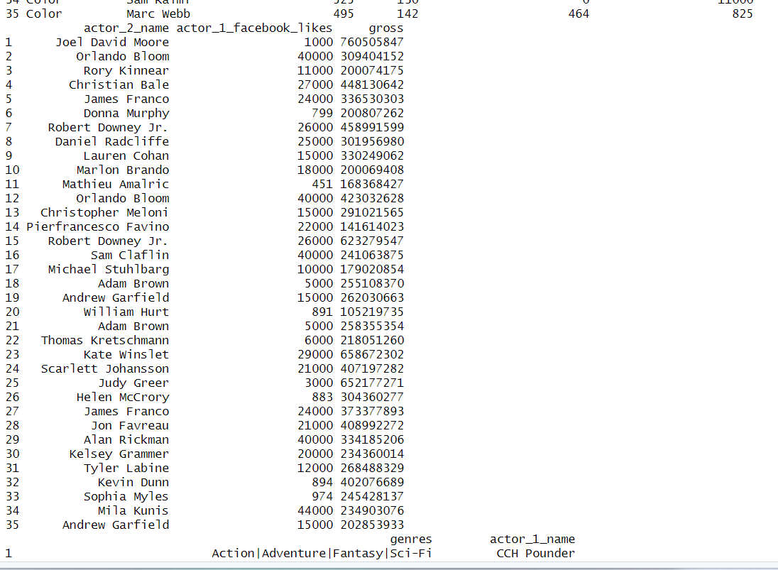
Finding 6: Genre Distribution
- Drama and Comedy dominate the dataset.
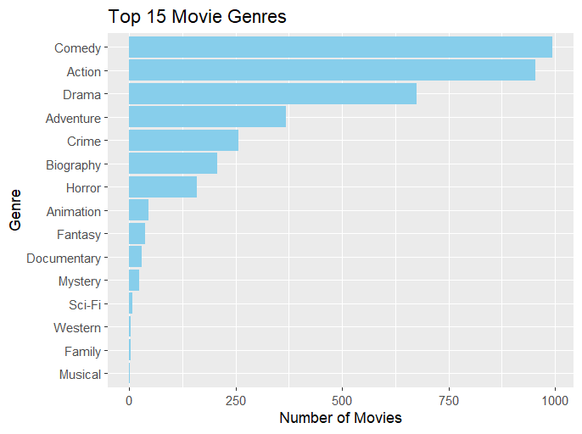
- Top 15 genres visualized; multi-genre combinations are common.

4. Conclusion
This project explored the Movie Metadata dataset through data cleaning, statistical analysis, and visualization. At the beginning, missing values and duplicate records were removed to improve data quality. New variables such as profit and return on investment were created to better understand the financial performance of movies.
Descriptive statistics (mean, median, mode, standard deviation, and interquartile range) were calculated for key variables including budget, gross revenue, profit, IMDb score, and duration. These measures provided insights into the overall trends and variability in the dataset.
Univariate and bivariate visualizations revealed important patterns. Histograms showed the distribution of IMDb scores, budgets while scatterplots highlighted the relationships between budget and gross revenue, IMDb score and profit, as well as ROI and IMDb score. Correlation analysis further demonstrated strong links between budget, revenue, and profit.
The genre analysis identified the top 15 most common genres, showing which types of movies are most frequently produced. This information, along with IMDb scores and profitability measures, helps to understand both audience preferences and market performance across different genres.
In conclusion, this project demonstrates how data science techniques can be effectively applied to real-world datasets. It highlights the importance of thorough data cleaning, descriptive analysis, and visualization in generating meaningful insights that support informed decision-making.

